**Medical History:**

Illness/operations (please include approximate dates):

Allergies:

**Family History of:**

Heart Disease: Yes / No Heart Attack: Yes / No

Stroke: Yes / No Epilepsy: Yes / No

High blood Pressure: Yes / No Glaucoma: Yes / No

Diabetes: Yes / No Asthma: Yes / No

Cancer: Yes / No Other (Please Specify):

**Regular Medication:**

(Please include name of medication and dose, if you have a repeats list please provide us with a copy)

**Please circle the most appropriate answer for each question in the table below:**

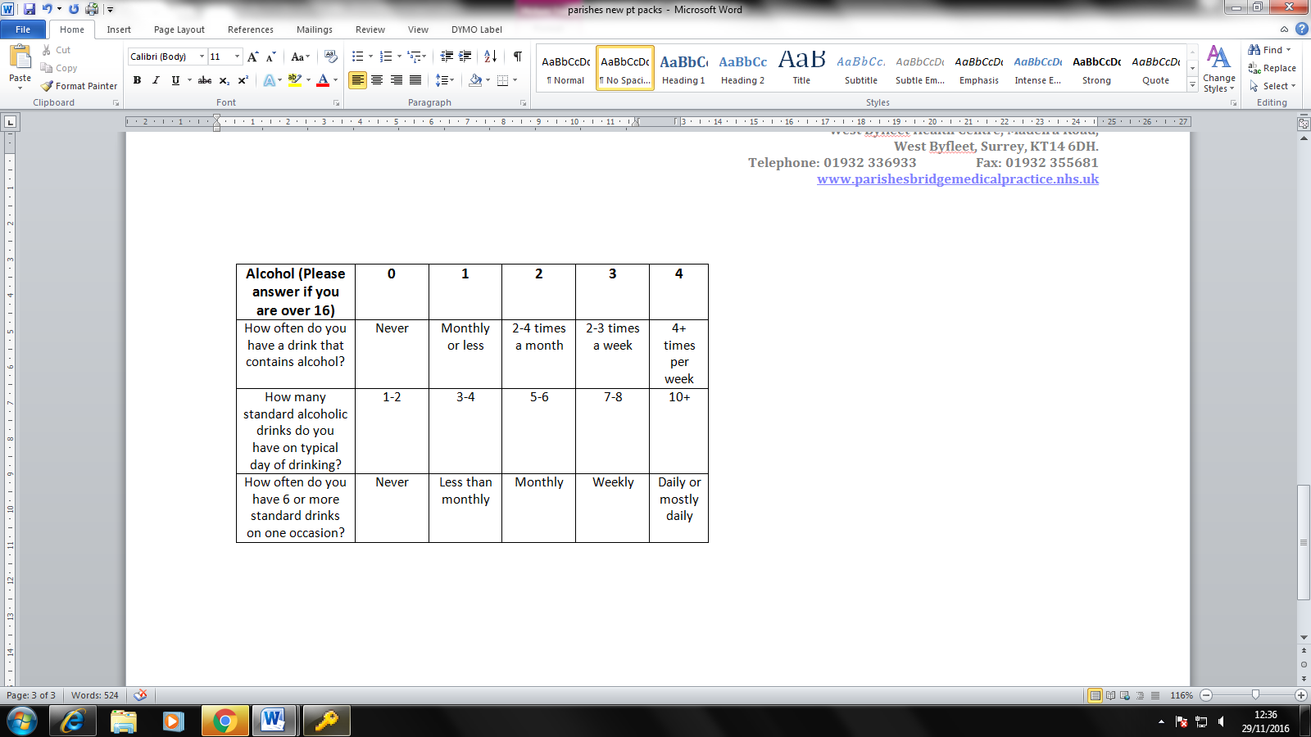

**Welcome to Parishes Bridge Medical Practice**

Please complete all parts of this registration form, as applicable, with as much detail as possible to help us register you with our Practice. It is especially important to tell us about any serious illnesses and any regular medications. **PLEASE COMPLETE THIS FORM IN BLOCK CAPITALS.**

**Please read out Practice Booklet with regards to GP training, research and home visits.**

In order to complete your registrations promptly please supply us with **two** of the following documents:

* Current passport
* Utility bill/rent agreement with your new address on
* Visa
* Photographic Driving Licence

If you require a repeat prescription you will need to have an appointment with a GP prior to us prescribing, please take a complete list of all your medications with you.

**Forename:**

**Surname:**

**Date of Birth:**

**Mobile Number:**

**Home Number:**

**Next of kin name**

**& telephone number:**

**Marital Status:** Single - Married - Divorced -

Widowed - Separated - Living with parents -

|  |  |  |
| --- | --- | --- |
| **Ethnicity Category** |  | **Please tick:** |
| **White** | British |  |
|  | Irish |  |
|  | Other White |  |
| **Mixed** | White & Black Caribbean |  |
|  | White & Black African |  |
|  | White & Asian |  |
|  | Other Mixed |  |
| **Asian/Asian British** | Indian |  |
|  | Pakistani |  |
|  | Bangladeshi |  |
|  | Other Asian |  |
|  | Sri Lankan |  |
|  | Korean |  |
| **Black/Black British** | Black Caribbean |  |
|  | Black African |  |
|  | Other Black |  |
| **Other Ethnic** | Chinese |  |
|  | Other Ethnic Category |  |
| **Not Stated** | Not Stated |  |

**Full address:**

**Number of People living in household:**

**Current occupation:**

**Do you have a carer?**

**If so, please provide their name and contact number:**

**Are you a carer?**

**If so, who for?**

**If you are on regular medication, please tick which pharmacy you would like your prescriptions to automatically go to:**

Lloyds West Byfleet - Boots West Byfleet -

Lloyds New Haw – Boots Byfleet Village –

May & Thompsons - Tesco Brooklands -

Cohens WBHC -

**Name of Previous Doctors :**

**Full Address of Previous Doctors:**

**Name of previous assigned GP:**

**Waist Circumference: **

**First Language (if not English – please state):**

**Smoking Status:**

Current Smoker: Yes / No – How many Daily?

Ex Smoker: Yes / No – Date stopped?

Never Smoked: Yes / No

**Smoking Status:**

Current Smoker: Yes / No – How many Daily?

Ex Smoker: Yes / No – Date stopped?

Never Smoked: Yes / No

**Height:**

**Weight: **

**To be completed all children under the age of 16:**

Parent / Carer name & contact number:

Name and address of Nursery / School:

**Children – Immunisations:**

We must have complete details of vaccinations and immunisations already performed. If you cannot remember dates then please give approximate dates and bring in your childs Health Record for checking.

**Vaccincation: Age: Date Given:**

BCG Birth

Diptheria / Tetanus / 2 months

Hib / Polio / Pneumococcal

Diptheria / Tetanus / Pertussis / 3 months

Hib / Polio / Meningitis C

Diptheria / Tetanus / Pertussis / 4 months

Hib / Polio / Meningitis C /

Pneumococcal

Hib / Meningitis C 12 months

Measles / Mumps / Rubella / 13 months

Pneumo

Diptheria / Tetanus / Pertussis / Pre-school

Polio

Measles / Mups / Rubella Pre-school

HPV (girls) 3 doses 12-13 years

Diptheria / Tetanus / Polio 13-18 years

Any others (please state):

**THIS IS FOR ADMIN USE ONLY:**

**Proof of address seen:**

Yes / No – Staff initials:

**Valid Form of Photographic ID seen:**

Yes / No – Staff Initials:

**Date Registration taken:**